# Connexions D1 mini

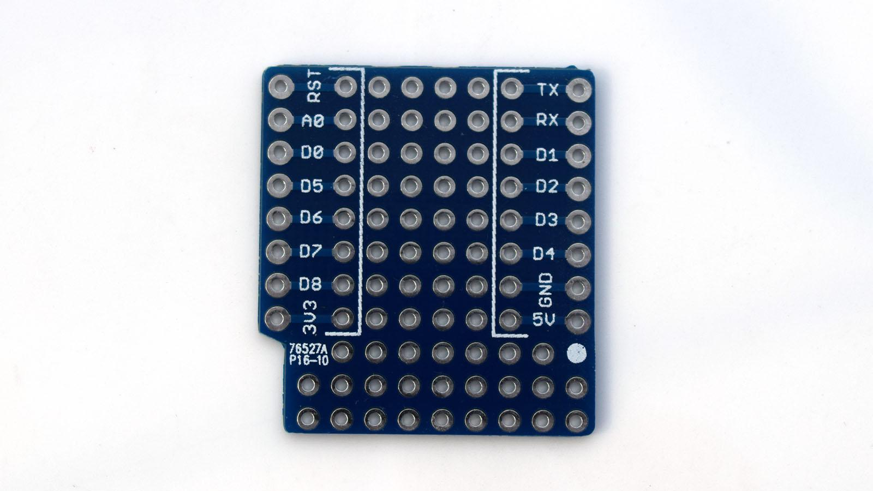

|  |  |  |  |
| --- | --- | --- | --- |
| D1 mini | Shield / mòdul | Ampliació | Notes |
| D0 |  |  |  |
| D1 / SCL | OLED I2C  DHT I2C  RTC I2C  Relay | SHT30 I2C  16 channel servo I2C  12 channel analog I2C |  |
| D2 / SDA | OLED I2C  DHT I2C  RTC I2C  RGB | SHT30 I2C  16 channel servo I2C  12 channel analog I2C  DS18B20 |  |
| D3 | 1 button |  |  |
| D4 | Semàfor RED |  |  |
| D5 | Matrix led CLK  Buzzer |  |  |
| D6 |  |  |  |
| D7 | Matrix led DIN |  |  |
| D8 | Semàfor GREEN |  |  |
| A0 |  |  |  |